Certificate of Analysis
Compound Name: Isopropyl-beta-D-thiogalactopyranoside
CAS No.: 367-93-1
Grade: Industrial grade
Quantity: 960 Mt
Lot No.: YBP-2021081201
Mfg data: Aug. 12th 2021
Analysis data: Aug. 12th 2021
Structure:
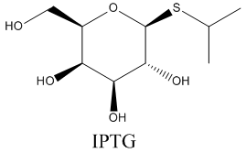
Item | Requirement | Result
Appearance | White crystalline powder | Complies
Purity | ≥99% | 99.61%
Solubility (Concentration) | 49.00 - 55.00 mg/ml | Complies
Solubility (Color & Turbidity) | Colorless, clear | Complies
NMR (D2O) | Consistent with Structure | Complies
Residual Detection of Dioxane Ring (GC) | Not Contain | Complies
Specific Rotation | -28.00°--33.00° | -30.4°


Conclusion: This batch of product meets our enterprise standard, Qualified



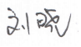
ANALYST: QC MANAGER: INSPECTOR:

